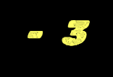

*ASSIG NM EN T - 3*

CREATE TABLE Customer ( cust_id INT PRIMARY KEY, cust_name VARCHAR(255), city VARCHAR(255),

grade INT

);

CREATE TABLE Salesman ( salesman_id INT PRIMARY KEY, salesman_name VARCHAR(255), city VARCHAR(255),

commission DECIMAL(5,2)

);

CREATE TABLE Orders ( ord_no INT PRIMARY KEY, ord_date DATE, purch_amt DECIMAL(8,2), cust_id INT,

salesman_id INT,

FOREIGN KEY (cust_id) REFERENCES Customer(cust_id),

FOREIGN KEY (salesman_id) REFERENCES Salesman(salesman_id)

);

INSERT INTO Customer VALUES

(1, 'Customer1', 'City1', 200),

(2, 'Customer2', 'City2', 300),

(3, 'Customer3', 'City3', 250);

INSERT INTO Salesman VALUES

(101, 'Salesman1', 'City1', 0.15),

(102, 'Salesman2', 'City2', 0.12),

(103, 'Salesman3', 'City3', 0.18);

INSERT INTO Orders VALUES (1, '2024-01-01', 1500, 1, 101),

(2, '2024-01-02', 800, 2, 102),

(3, '2024-01-03', 1200, 3, 103);

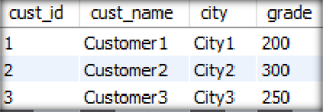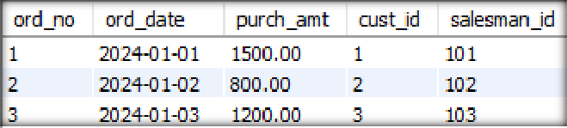

:: TABLES ::

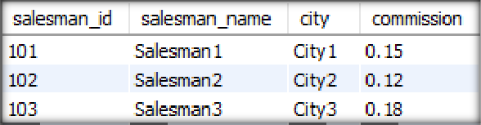

QUESTION – 1:

Write a SQL query to find the salesperson and customer who reside in the same city. Return Salesman, cust_name, and city.

Query

select Salesman.salesman_name,Customer.cust_name,Customer.city from Salesman inner join Customer on Customer.city=Salesman.city;

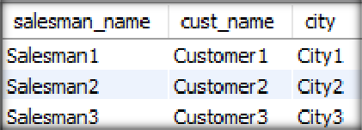

QUESTION – 2:

Write a SQL query to find those orders where the order amount exists between 500 and 2000. Return ord_no, purch_amt, cust_name, city.

Query

select ord_no,purch_amt,cust_name,city from Orders inner join Customer on Orders.cust_id=Customer.cust_id where Orders.purch_amt between 500 and 2000;

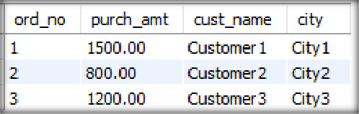

QUESTION – 3:

Write a SQL query to find the salesperson(s) and the customer(s) he represents. Return Customer Name, city, Salesman, commission.

Query

select Customer.cust_name,Customer.city,Salesman.salesman_name,Salesman.commission from Salesman inner join Customer on Customer.city=Salesman.city;

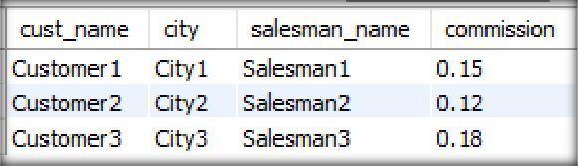

QUESTION – 4:

Write a SQL query to find salespeople who received commissions of more than 0.12 percent from the company. Return Customer Name, customer city, Salesman, commission.

Query

select Customer.cust_name,Customer.city,Salesman.salesman_name,Salesman.commission from Salesman inner join Customer where Salesman.commission>0.12;

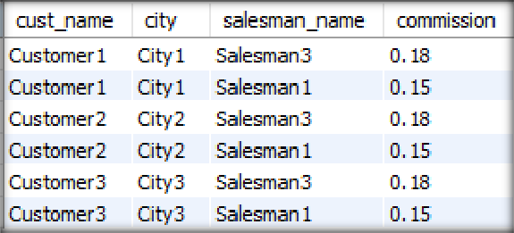

QUESTION – 5:

Write a SQL query to locate those salespeople who do not live in the same city where their customers live and have received a commission of more than 12% from the company. Return Customer Name, customer city, Salesman, salesman city, commission. Query

select Customer.cust_name,Customer.city,Salesman.salesman_name,Salesman.city,Salesman.commission from Salesman inner join Customer on Customer.city!=Salesman.city where Salesman.commission>0.12;

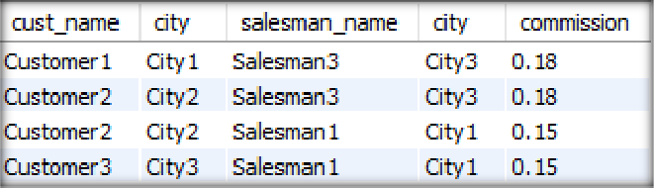

QUESTION – 6:

Write a SQL query to find the details of an order. Return ord_no, ord_date, purch_amt, Customer Name, grade, Salesman, commission.

Query

select

Orders.ord_no,Orders.Ord_date,Orders.purch_amt,Customer.cust_name,Customer.grade,Salesman.salesma n_name,Salesman.commission

from Orders

inner join Customer on Orders.cust_id=Customer.cust_id

inner join Salesman on Orders.salesman_id=Salesman.salesman_id;

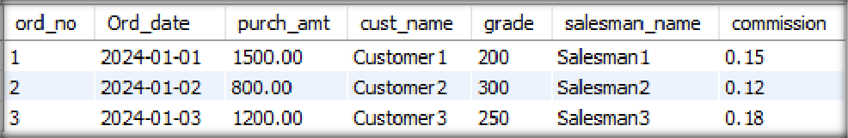

QUESTION – 7:

Write a SQL statement to join the tables salesman, customer, and orders so that the same column of each table appears once and only the relational rows are returned.

Query

SELECT

salesman.salesman_id, salesman.salesman_name, customer.cust_id,

customer.cust_name, orders.ord_no,

orders.ord_date, orders.purch_amt

FROM orders

JOIN salesman ON orders.salesman_id = salesman.salesman_id JOIN customer ON orders.cust_id = customer.cust_id;

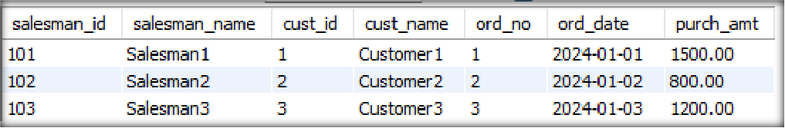

QUESTION – 8:

Write a SQL query to display the customer name, customer city, grade, salesman, salesman city. The results should be sorted by ascending customer_id.

Query

select Customer.cust_name,Customer.city,Customer.grade,Salesman.salesman_name, Salesman.city from Customer

inner join Salesman on Customer.city=Salesman.city order by Customer.cust_id asc;

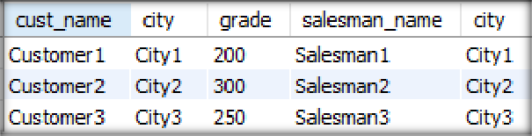

QUESTION – 9:

Write a SQL query to find those customers with a grade less than 300. Return cust_name, customer city, grade, Salesman, salesmancity. The result should be ordered by ascending customer_id.

Query

select Customer.cust_name, Customer.city,Customer.grade,Salesman.salesman_name,Salesman.city from Customer

inner join Salesman on Customer.city=Salesman.city where Customer.grade<300

Order by Customer.cust_id asc;

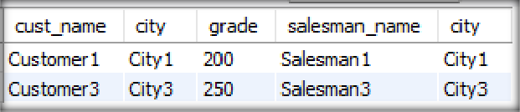

QUESTION – 10:

Write a SQL statement to make a report with customer name, city, order number, order date, and order amount in ascending order according to the order date to determine whether any of the existing customers have placed an order or not.

Query

SELECT C.cust_name, C.city, O.ord_no, O.ord_date, O.purch_amt FROM Customer C LEFT JOIN Orders O ON C.cust_id = O.cust_id ORDER BY O.ord_date ASC;

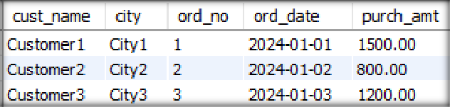

*ASSIG NM ENT - 4*



QUESTION - 1

**Retrieve all records from CHALLAN_HEADER**

Query

SELECT * FROM CHALLAN_HEADER;

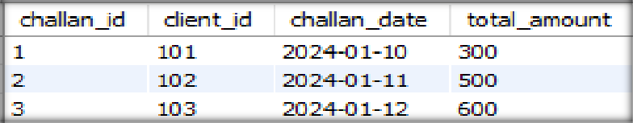

QUESTION - 2

Retrieve all records from CHALLAN_DETAILS

Query

SELECT * FROM CHALLAN_DETAILS;

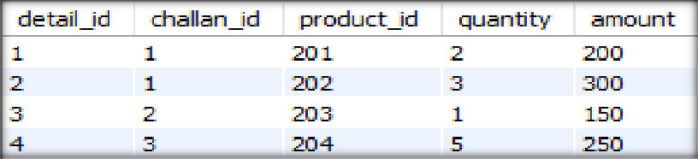

QUESTION - 3

Retrieve details of a specific challan along with associated products

Query

select CH.challan_id,CH.client_id,

ch.challan_date, ch.total_amount, cd.detail_id,cd.product_id,

cd.quantity,cd.amount

from

CHALLAN_HEADER as CH

Join CHALLAN_DETAILS AS CD on CH.challan_id = CD.challan_id WHERE CD.challan_id = 1;

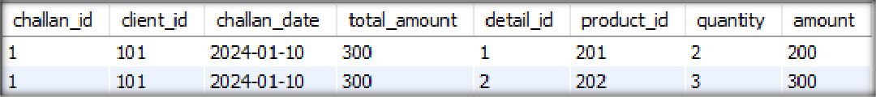

QUESTION - 4

Retrieve details of products in a specific challan

Query

select product_id from challan_details where challan_id=1;

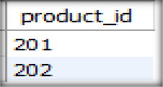

QUESTION - 5

Retrieve all Challan Headers with total amount greater than 500.00

Query

select *

from CHALLAN_HEADER

where total_amount>500;



QUESTION - 6

Retrieve all distinct clients who have made a challan

Query

select distinct client_id from CHALLAN_HEADER GROUP BY

client_id ;

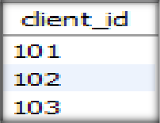

QUESTION - 7

Retrieve the total quantity and amount for each product across all challans:

Query

select product_id, sum(quantity) as total_quantity, sum(amount) as total_amount from challan_details

group by product_id;

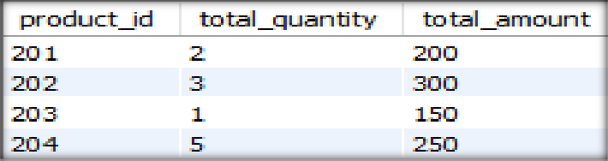

QUESTION - 8

Retrieve the challan details along with the client information for a specific challan

Query

select ch.challan_id,ch.client_id,ch.total_amount,cd.detail_id,cd.product_id,cd.quantity,cd.amount from challan_header ch

join challan_details cd on ch.challan_id=cd.challan_id where ch.challan_id = 1 ;

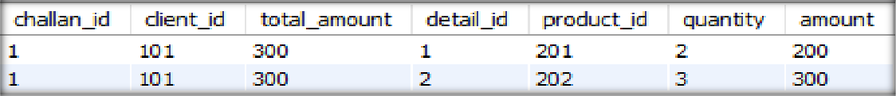

QUESTION - 9

Retrieve the total amount for each client based on all their challans

Query

select distinct client_id,sum(total_amount) from challan_header

group by client_id ;

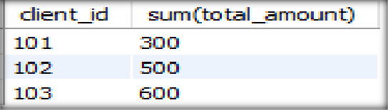

QUESTION - 10

Retrieve the products with quantity greater than 2 in any challan

Query

select product_id, quantity from challan_details

where quantity > 2 ;

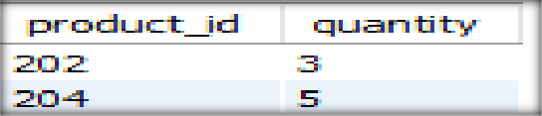

QUESTION - 11

Retrieve all challans along with the total quantity and amount for each challan

Query

select challan_id,

sum(quantity) as total_quantity, sum(amount) as total_amount from challan_details

group by challan_id;

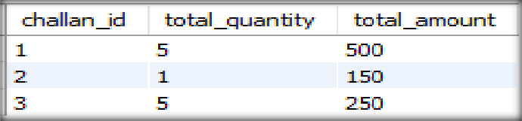

QUESTION - 12

Retrieve the details of the latest challan made by each client

Query

select max(challan_id),client_id,max(challan_date) from challan_header group by client_id;

